# Sensor Usage Instructions

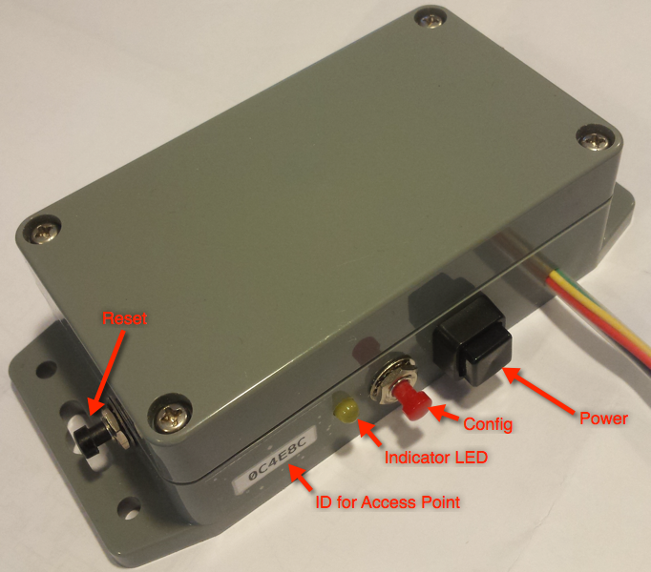

## General

* Sensor captures vibration & temperature. The major frequency of vibration is calculated. These sensors are best suited to rotational equipment but can be used in any situation where temperature and/or vibration is significant.
* Uses 3xAA Alkaline batteries. Remove 3 screws to access battery. Ensure black face of battery case points towards switches when reinstalled.
* When detaching sensor, always pull only white plastic plug - not the wire.
* TLS encryption is used to transmit data and requires port 443 to be open.

## Configuring & Use

To configure unit:

* Press & hold red configure button
* Press & release black reset button (on short side of box)
* Release red button
* Look for hotspot named ABCDEF Sensor (ABCDEF is the hex number on the box).  Password is IBMSensor
* Fill in the details on the config screen
* Needs WiFi name, password, IoT Platform Org, Device Type, Device ID, Token
* Per Hour field is readings per hour.  If configured to send 1 reading per hour battery life will (hopefully!) be around 1 year.  More frequent readings will shorten battery life – eg 6 per hour will last about 2 months. For testing, you can enter 0 in this field. This will result in the sensor continually sending data every 3 seconds. Battery life will not be long in this mode!

Black square button is on/off.  The unit will not fully turn off for up to 2 minutes after pressing. This can be forced by pressing the reset button after switching off.

When switched on, pressing the reset button will make the yellow LED flash (provided the batteries are not flat!)

Battery reading (sent in IoT message) below 3.0V is low.  Below 2.9V needs replacing.

* If readings stop arriving, press reset button & check for yellow LED flash.

Normal behaviour after reset and when sending data (when it is configured & can connect to IoT Platform & sensor is connected) is:

* Short flash (**resetting**)
* Long flash (few seconds) (**connecting to WiFi**) If the yellow LED remains on, it is waiting for you to configure it - maybe because WiFi is off.
* Off (few seconds) (**Connecting to IoT Platform, reading sensor, sending message**)
* Short flash (**message sent correctly, going to sleep**)

If the LED remains on for more than a few seconds, it is unable to connect to the access point and has entered configuration mode.

On demand readings may be sent by pressing the reset button.

## Troubleshooting

|  |  |
| --- | --- |
| **Symptom** | **Resolution** |
| No LED flash when pressing Reset | Switch on or replace batteries |
| 10 short flashes | Sensor not responding. Carefully detach & reattach sensor |
| 5 short flashes | No WiFi connection. Device will enter configuration mode for 30 seconds, then will turn off & try again after the configured interval. Either switch on the WiFi or reconfigure the device. |
| 4 short flashes | No IoT Platform connection. Device will switch off & try again after the configured interval. This can be caused by any of the following:  IoT Platform not available  Wrongly configured org ID – reconfigure device  Wrongly configured device data (ID, token, type) – reconfigure device or register device ID on IoT Platform |
| 2 short flashes | Unable to send IoT Data. Device will retry after configured interval. Usually caused by network issues. |
| Inconsistent data | Poor connection to sensor. Try unplugging & reattaching sensor. |
| LED remains on for up to 30 seconds | Device has automatically entered configuration mode due to inability to access WiFi. |
| LED remains on | Device has been put into configuration mode by pressing the config button. |
| No data on IoT Platform | Ensure device configuration matches IoT Platform. Check ID, token, org ID, device type. |

## Data Display

Sample display of data from device. Contact the manufacturer for a copy of the Node Red flow used.

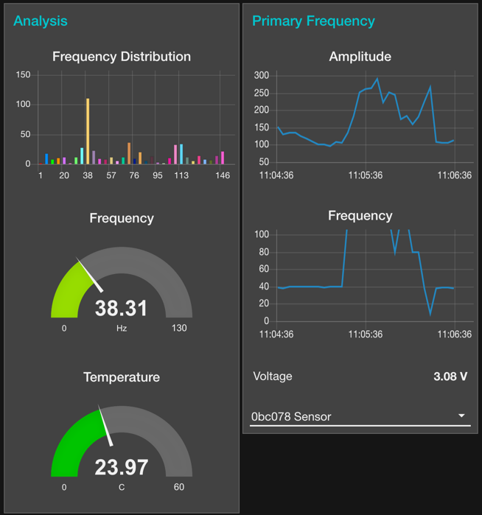

The data can also be viewed in the IoT Platform Cards

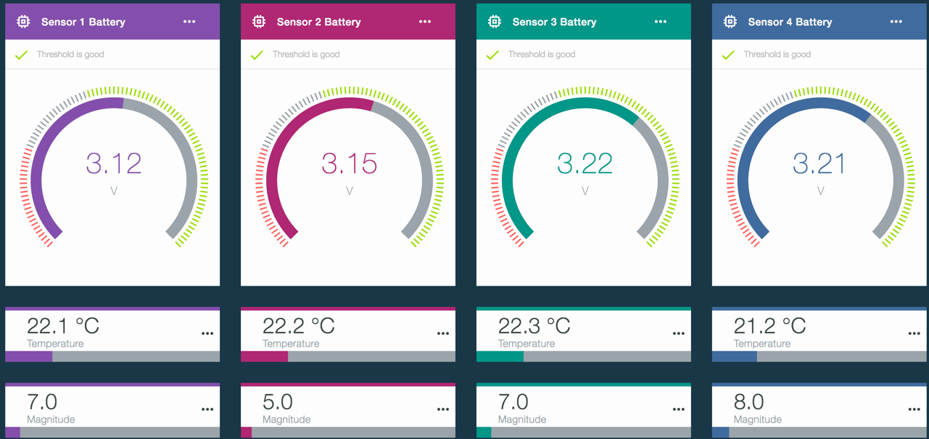

## IoT Data Format

The data sent to the IoT Platform is as follows

d.Frequency – Major frequency of vibration

d.Magnitude – Amplitude of vibration

d.Temperature – Temperature in C

d.FreqArray[0..127] – Array of frequencies & amplitudes. Eg d.FreqArray[17].f and d.FreqArray[6].v

d.Volts – Battery voltage. Below 3 is nearing replacement. Below 2.9 is critical.

d.MAC – Name of the access point used for configuration

## Sample data packet

{

"d":{

"MAC":"0bc078 Sensor",

"Freq":120.08,

"Magnitude":175.00,

"Temperature":23.82,

"FreqArray":[

{"f":0,"v":0},

{"f":2,"v":5},

… … …

{"f":147,"v":6}

],

"Volts":3.08

}

}